**Normal Distribution**

1. Normal Distribution is also called as Gaussian Distribution
2. It is the probability Distribution that is symmetric about the mean.
3. Showing data near mean is more frequent than data far from the mean

***Normal Distrbution has follwoing Properties:***

1. The normal curve is symmetrical around the mean
2. The total mean is the centre and divide the data into two havles
3. The total area under the curve is 1
4. The range is from -infinity to + infinity
5. 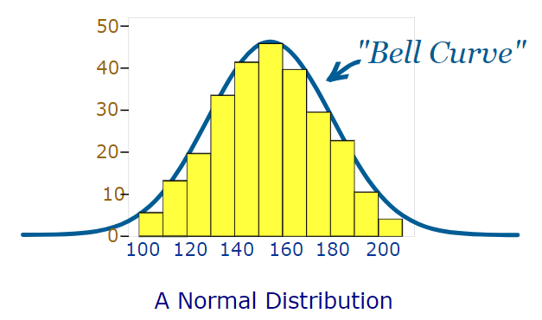
6. mean=mode=median
7. Area under the curve is symmetrical
8. Center describe the mean and distribution is describe by the sigma (standard deviation)

***Following assumptions and caluclation:***

1. Various statistician has done reseach and found that data between +1sigma and -1 sigma the % of data is 68.26%
2. found that data between +2sigma and -2 sigma the % of data is 94.26%

Have you ever thought for different mean and standard deviation the data will still follow normal distribution hence to make a certain standard we come up with z distribution also called as standard z distribution which says mean =0 and standard deviation =1

**z=x-mu/sigma**

**R code to dtermine the z score :**

pnorm(first,second,standarddeviartion)

**Normal Q-Q Plot**

In order to check the given variable is the normally distributed or not we go for normal quantile quantile plot

Where at x-axis we have z values

Y-axis sample data

***Rcode:***

Qqnorm

qqline